

The Lighthouse
Zion & Trinity Lutheran Churches
950 Huron
St. Ignace, MI 49781

Address Service Requested

Nonprofit Org.
U.S. Postage
PAID
St. Ignace, MI 49781
Permit No. 55
«First_Name» «and» «Spouses_Name» «Last_Name»
«Address»
«City», «State» «Zip_Code»

The Lighthouse
Zion & Trinity Lutheran Churches
950 Huron
St. Ignace, MI 49781

Address Service Requested

Nonprofit Org.
U.S. Postage
PAID
St. Ignace, MI 49781
Permit No. 55

THE LIGHTHOUSE

Newsletter for November 2015

105 Your word is a lamp to my feet and a light for my path. Psalm 119:105

Message from Our Pastor

Sisters and Brothers in Christ,

As I sit here looking out my office writing this letter, I noticed the last of the maple leaves are falling off the maple tree outside in the parsonage yard. For me looking at the fall colors, and feeling the chill in the air that could only mean one thing one of my favorite holidays is rapidly approaching, Thanksgiving!

I can taste it now a moist turkey, cranberries, my mom’s sausage stuffing, mashed potatoes and gravy, being from Iowa you have to have the buttered corn, and then to top it all off pumpkin pie. Then of course there is that blessed time in the comfy chair falling asleep watching the football game! But there is something more important than the food and football, for the last 10 years Catherine and I have hosted thanksgiving for my family, together we get up in the wee hours of the morning and begin the preparation of the food, and we both love it, and why we love it is pretty simple, and that is to serve the people we love. Everyone gathered around the table, is something that warms our hearts, and for this we truly give thanks. It’s one of the main reasons we have been doing the Sunday night invites, the food and sharing of stories has been a wonderful way to get to know each other. (So if the Sunday dates on the list don’t work for you we will gladly change it! So please ask Catherine and I, we would love to have you over.)

There is something about the breaking of bread that is very special, we see it throughout the bible from the Old Testament to the New Testament, it’s that coming together and giving thanks for all that we have been given that makes it special. God has given us so many gifts, and it’s wonderful to share them with everyone. As Christians we really do celebrate Thanksgiving every week when we come to the Lord’s Table for communion, where all are welcome to taste and see that the Lord is good. It’s doesn’t matter if you’re a long time member of the church family, or someone who is just passing through. I have had numerous phone calls from out of town people asking if we are having communion on Sunday. In one of those phone calls the gentleman asked me if all are welcome. It brought joy to my heart to tell him yes. And when he asked “Are you sure?” my smile got even bigger when I told him “yes I am” because I am the Pastor! God welcomes all, without judgment, to the table. It is in that bread and wine where all of our sins are forgiven, through Christ’s precious body and blood. It is given so freely for us, even though we fall short, to the glory of God. For that I am truly grateful!

I want to wish you all a very blessed and Happy Thanksgiving!

Yours in Christ,
Pastor David

Newsletter

The Newsletter was not adopted.

All Saint’s Day

November 1st is All Saint’s Day. This is a day in the church when we remember all the baptized who’ve gone before us. In the past year, we have buried the following saints:
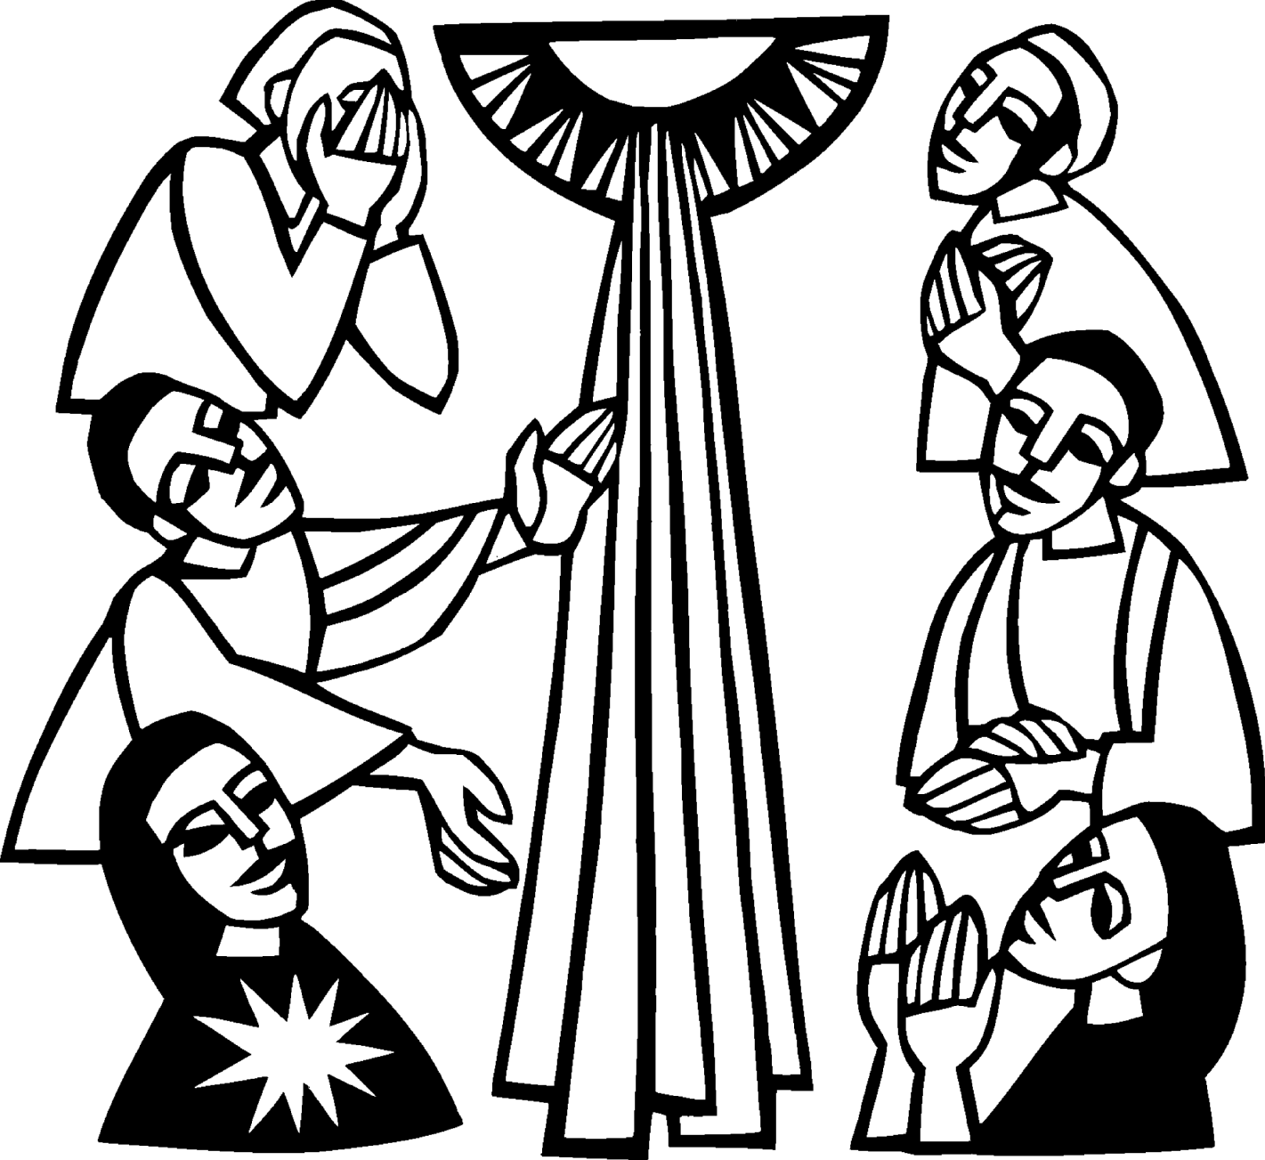

Ralph Coburn
Cole Haan
Ric Mulholland
Joy Olsen
Edythe Sorenson Ritter
Rev. Phillip Schaeffer
Mitchell Snyder
Pastor Lewis Thompson and his son John

Noisy Offering

The noisy offering for November 1st will go to The Food Pantry. Need is always greater at this time of the year.

Sunday School

Sunday School will be from 10 to 10:45 a.m. on the 1st, 2nd and 3rd Sundays of each month for Pre K thru 5th graders.

Confirmation

Confirmation will meet on the 1st and 3rd Sunday of the each month from 6 - 7:30 pm.

Pastor will be gone

Note: Pastor will be gone to a First Call Theological Retreat in Wisconsin, Nov 8-11.

Crazy Crafter Dayz

Come join us on November 13th (6 pm - 12 am) and November 14th (6 am - 10 pm) for Crazy Crafter Dayz.

Bring your scrapbooking, quilting, holiday crafting or other supplies. Each crafter will have a table to work on, with access to outlets if needed. Also bring a snack to pass around.

Come for a few hours or both days. There will be fellowship and games the entire time. Everyone welcome, we look forward to seeing you.

If you have questions call Cathie at the parsonage (906) 984-2051.

NOIZ

NOIZ will be at 6 – 7 pm on November 22nd (note date change). We will be making Thanksgiving food baskets followed by bowling.

Blanket need

Blankets and quilts are desperately needed at this time. Any extra blankets or quilts, which you would like to donate, should be brought to the church and they will be distributed to those in the area who need them.

Advent is Coming!

We will be decorating the church for Advent, following the service on Sunday, Nov 22nd. Please help out if you can.

Anniversaries in November

November10 Judy & Don Massey

Birthdays in November

November 3 Tim Idalski
4 Ernie Vallier
4 Linda Wilkins
7 Rita LaVake
11 Kathy Marshall
11 Samantha Wyers
12 Shirley Winberg
15 Nancy Hardy
15 Alicia LaLonde
17 Faith Gaubault
17 Wyatt Huhn
17 Kyra Spencer
18 Lori Bowlby
19 Connie Olsen
19 Justin Stenson
22 Lisa Gamble
23 Shirley Campbell
25 Dawn Akers
26 Misti Gamble
28 Gloria Marshall
29 Jessie Rogers
30 Virginia Hopper
Baptimal Anniversaries

November 2 Joshua LaJoice
November 12 Misti Gamble
November 13 Tim Idalski
November 14 Adrian Coleman

November 14 Madison Coleman
November 17 Kristen Olsen
November 21 Duane Gamble
November 25 LaRoy Hill
November 27 Mike Wilkins
November 27 Mandy Fenlon

Calendar Note

Daylight Savings Time changes on November 1st. Turn your clocks back. Smoke detector batteries should be replaced at least once a year. People often change them when the clocks change.

Trinity Worship Families

Nov 1 Chalmers Family
Nov 8 Rose Family
Nov 15 Kennedy Family
Nov 22 Movalson Family
Nov 29 Baron Family

Zion Funeral Committee Aug - Nov

Team Leader: Linda Wilkins (430-1465)
Co-leader: Rita LaVake (906) 298-0005

Servants for Zion

Ushers & Greeters

Nov 1 Nicole Garen Family
Nov 8 Sam LaVake Family
Nov 15 Confirmation Youth
Nov 22 Amy Dodds Family
Nov 29 Mark & Carol Elmblad

Lectors

Nov 1 Betsy Turf
Nov 8 Lorraine Graham
Nov 15 Sandy Feleppa
Nov 22 Cathie Tielbar
Nov 29 Paul Shepard

Communion Assistants

Nov 1 Paul Shepard
Nov 8 Jerry Fenlon
Nov 15 Fred Feleppa
Nov 22 Nicole Garen

Acolytes

Nov 1 Bailey Ryerse
Nov 8 Ryan LaVake
Nov 15 Emma Feleppa
Nov 22 Ellie Tielbar
Nov 29 Donovan Insley

Altar: Karen Schlehuber
Money Counters: Carol Elmblad & Martha Sjogren

Council Meetings

Zion Council – 6:30 pm, November 17th
Trinity Council Meeting – 6:00 pm, November 18th

Zion’s Council Members

President: Lana Lennington 643-6576
Vice-President Paul Shepard 984-2069
Secretary: Lorraine Graham 643-8419
Co-Treasurers: Dawn Akers 643-7552
Co-Treasurers: Lana Lennington 643-6576
Fred Feleppa 643-6793
Jerry Fenlon 643-8730
Nicole Garen 298-0490
Tim Idalski 643-6574

Trinity’s Council Members

President: Jerri Rose 292-5570
Vice-President Tracy Movalson 292-5581
Secretary: Sharon Chalmers 292-5440
Treasurer: Pega Kennedy 292-5633
Co-Treasurer: Jim Rose 292-5570
Financial Secretary: Tom Gustafson 292-5460
WELCA: Pega Kennedy 292-5633
John Kennedy 292-5633
Jim Dyer 292-5433
Lois Movalson 292-5581

Treasurer's Report for Zion
January 1, 2015 to October 19, 2015
Income:
 | Amazon Smile Foundation | 12.58
 | Building | $ 268.00
 | Church Use Income | $ 150.00
 | Thrivent Financial Income | $ 719.00
 | General | $ 41,100.00
 | Trinity Share | $ 8,499.74
 | TOTAL |  | $ 50,749.32
Expenses:
 | Administration | $ 4,973.60
 | Benevolence | $ 5,014.59
 | Church Maintenance | $ 12,246.19
 | Education | $ 591.20
 | Parsonage Maintenance | $ 2,193.44
 | Pastoral | $ 16,157.68
 | Worship | $ 8,307.52
 | --To Building Fund | $ 108.00
 | --To LCF Loan | $ 0.00
 |  |  | $ 49,592.22
 |  |  | 1,157.10
***********************************************************
General fund balance: |  |  | $ 1,181.47
Kitchen/Building Fund balance |  |  | $ 1,033.57
General fund owes building fund: |  |  | $ 160.00
General fund owes Mission Endowment fund: |  |  | $ 7,995.00

Zion Lutheran Council Meeting
October 20, 2015
Present: Nicole Garen, Lorraine Graham, Fred Feleppa, Lana Lennington, Dawn Akers & Pastor Tielbar. (There were not enough members, at any given time, to make official decisions)

Meeting called to order at 6:45 pm.

Pastor Dave opened with devotion from Martin Luther.

Pastor's Report:

19 visits
3 counseling opportunities
1 youth activity
1 youth education
1 adult Bible Study

Confirmation has started. We currently have 9 students. 4 of them are set to be confirmed this spring. We need new cinctures for the acolyte gowns.

We have had one Sunday of “Sunday School”. We hope we will get more students as the word gets out.

We have had one NOIZ meeting. Currently there are 9 youth signed up. They unanimously voted on doing a mission trip next summer.

Treasurer’s Report: It was presented and discussed.

Secretary’s Report: It was presented and discussed

OLD:

The elevator is still not working.

We still need to update bank signatures. We did not receive reports from all the committees. We need to have at least quarterly statements from each committee.

NEW:

Pastor Dave will order 4 new cinctures for the acolytes

We had a discussion on who should be placed on All Saints list. Lana suggested, that next year, anyone who passed away on the prayer list should be included on the All Saints list.

It was decided that the council would need to have a strategic planning meeting to check the constitution for revisions and discuss the duties of each council member in preparation for the Annual Meeting.

The strategic planning meeting will be on November 5th at 6 p.m. We will also meet for our regular council meeting on November 24th at 6:30 p.m.

It was suggested that people coming off of the council could go on to the mission endowment committee.

Pastor Dave suggested that we do a mailing asking for current telephone numbers and email addresses. Dawn suggest we include it in with the stewardship mailing to save money.

Lorraine asked if we should include the Episcopalians on the new usher list coming out in January. We decided to include them if they were able.
It was suggested that we put into the bulletins and the newsletter, that blankets and quilts are desperately needed at this time. Any extra blankets or quilts should be brought to the church and they will be distributed to those in the area who need them.

Cathie Tielbar presented to the council her plan for a Crafting week-end to be held at the church on Nov 13th & 14th. People could come in and out at their own discretion. It was decided that there would be no cost but people should bring a dish to pass on Saturday. She will write up a paragraph to go into the newsletter.

NOIZ will be held on the 22nd in November so they can make up Thanksgiving food baskets. They will also be going bowling. The time is not yet decided.

Adjourned at 8:10 pm with Lords Prayer

Respectfully submitted,
Lorraine Graham, Council Secretary

Trinity Council Meeting
October 21, 2015

Present: Pastor Dave, Tom Gustafson, John and Pega Kennedy, Jerri and Jim Rose, and Tracy Movalson.

Meeting started at 6 p.m. Pastor Dave opened with a devotion from “Seize the Day” by Dietrich Bonhoeffer.

Pastors report:

For our Bible study we will start a six study that will have work books. The council approved to purchase the workbooks and we will study the book of Romans.
Pastor Dave shared with us the visitations and his activity for the month.

Secretary's report was read and approved.

Treasurer's report was read and approved.

Financial Secretary report was read and approved.

Old business:

Allen Stage will be at the church Thursday to make repairs to the stained glass windows.

Tracy purchased the scanner for the church to scan the history books. Tracy and Sharon will head up the scanning project.

Discussion resumed on repairing the stained glass windows. Rain leaks through them so we need to check the seals.

New business:

Statement of intent from the Synod for benevolence pledge to be tabled until the annual meeting.

Tracy will make a withdrawal from our thriving funds to donate to our missionary.

We determined that December 5th will be our next community dinner.

Meeting was adjourned at 6:45 p.m. with the Lord's Prayer.

Respectfully Submitted,
Tracy Movalson

Prayer List

(If you would like someone added to the prayer list, call the church at 906-643-7870)

Jim Dyer, Carl & Mary Belonga, LaTaunya Paquin, Phil Richel, Barb Lehto, Charlie Lamoreaux, Beth Ann Amacher, Joel Morabito, Joanne Truman, Greg Mitchinson, Kelli Morrison, Jim Rose, Troy Johnston, Dave Movalson, Pega Kennedy, Jim Ryerse, Steve Ingalls, Tom Coffey, Lance Litzner, Jim Scott, Ernie Langstaff, J.C. Kelly, Karla Wildberger, Kathy Perry, Sara Suchodolski, Lori Bowlby, Ann Yandell, Travis Rickley, Shirley Mitchinson, Sonja Brown and the families of Megan Ward, Ralph Coburn, Ric Mulholland, Pastor Lewis Thompson, and Mitchell Snyder.

Directory Update

It has been noted that the Directory we have been using from 2013 is in need of corrections and updating. If you have changed your address or telephone number since the directory was printed, please let the Pastor know.

Contact Information

Pastor David Tielbar may be reached at 906-984-2051 or at david.tielbar6@gmail.com. In an emergency, you can reach the Pastor’s cell phone at (563) 880-4512. Church telephone: 906-643-7870 - Answering machine. The secretary will usually be in the office on Tuesday and Thursday mornings from 9 – 12

Community Thanksgiving

We will be having a Community Thanksgiving Service at the United Methodist Church on Sunday, November 22nd at 7:30 pm.

Annual Turkey Dinner

The 100th Annual Turkey Dinner & Craft Sale sponsored by the United Methodist Church will be on Thursday, November 5th, 5 – 6:30 pm at the LaSalle High School Cafeteria. Adults $10, Kids (5-12) $5, Take-out $11. (Dedicated to the memory of Ruthie Visnaw)

Mackinac Co. Children’s Toy Drive

Sunday, November 1st, 8:30 am - 12:30 p.m: There will be a Pancake Breakfast fundraiser at Mackinac Grille,. $6 - adults, $4 - 10 years and under. Proceeds to benefit the Mackinac County Children’s Toy Drive.

They will also be sponsoring a sub and bake sale at Family Fare on November 7th from 8:30 am – 2 pm

Animal Shelter bake sale

The Mackinac Animal Aid Association will be holding a bake sale at Family Fare on November 14th starting at 10 a.m. They will also be selling their Calendars for $10.

